What do we know using our current data?

1) When the students visit the page, do they just visit, or explore the website more by clicking into related internalLink?

To analyze this, for both cohorts, 2510 cohorts (2025-08-01 to 2025-12-10) and 2520 cohorts (2026-01-10 to 2026-05-10), I have analyzed how many students transitioned from the pageview event to the internalLinkClick event in order to understand how many students clicked other internal links after coming into the website, which would let us know whether students actually explore the internal links within the website.

For this analysis, I have used posthog AI and let it make a funnel, as it measures how many users complete a sequence of steps in “order”. In this case, our two steps would be visiting a page ($pageview) and clicking an internal link (internalLinkClick). I made it so that it counts how many students who did step 1 (visiting a page) also went on to do step 2 (clicking an internal link) within a set time window (I set it up as 30 minutes, but if you ask why specifically 30 minutes, I do not have a specific answer for that yet). As a result, I have gotten the results for both cohorts :
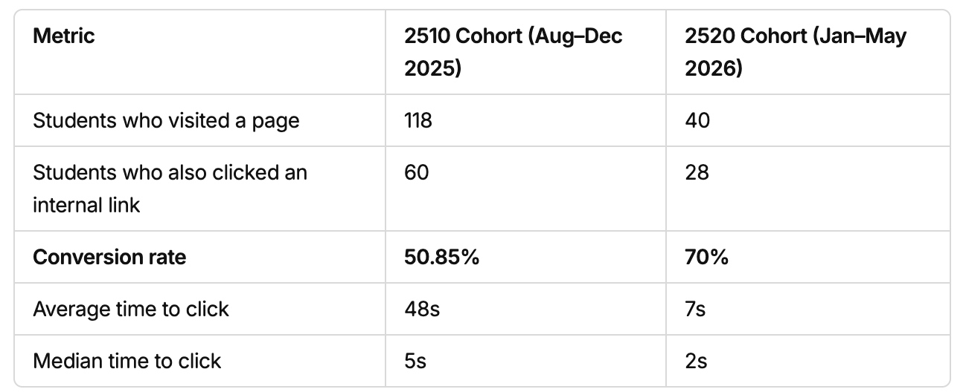

According to the table, when students came into a particular page within the website, for the 2510 cohort, 50.85% of the students converted to another link within the website, and for the 2520 cohort, 70% of the students converted to another link within the website, which tells us how the 2520 cohorts were more active as in they had a tendency to explore more contents in the website. Which pages they converted to, and which pages were the most famous among the students would be analyzed soon in this document.

2) How do the students use the resource pages?

For this question, I analyzed the frequency of $pageview for each resource page in descending order so that we can understand which resource pages were viewed the most, reasonably analyzing which resource pages may have been helpful for the students throughout the two terms. The result that I got was :
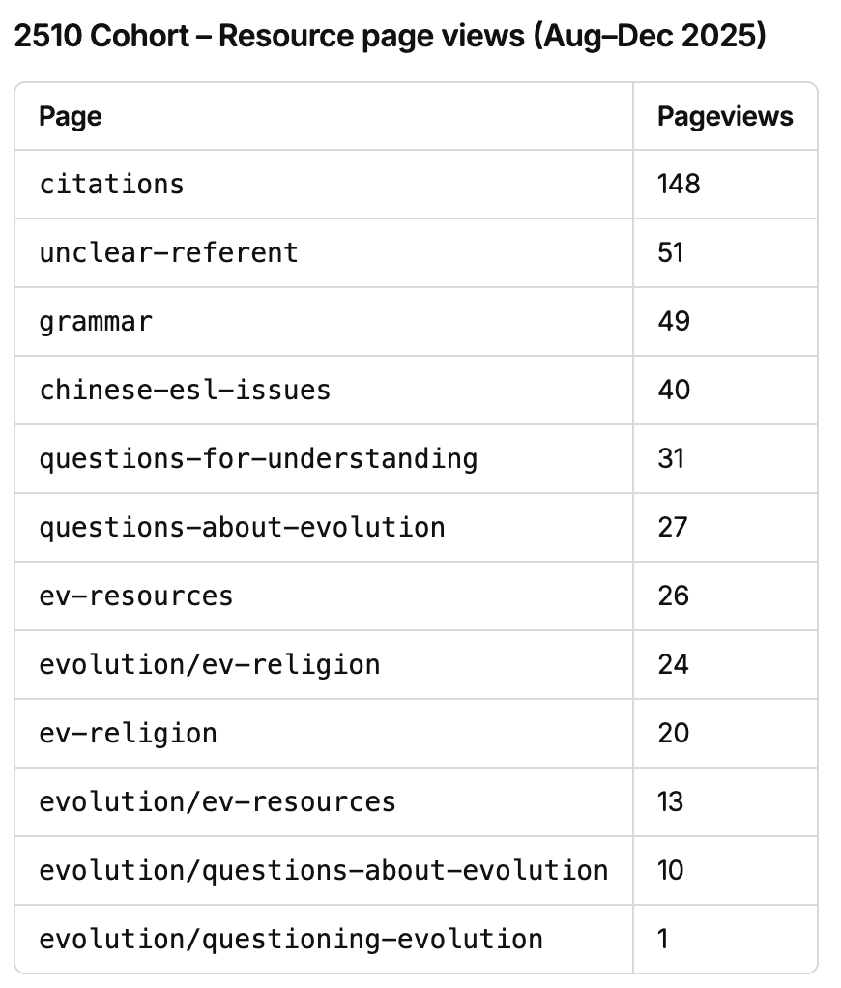
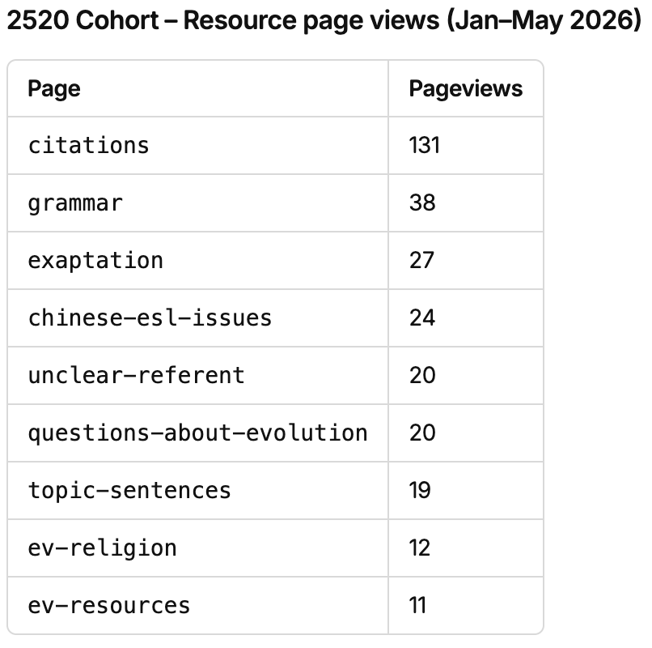

For both cohorts, the “citation” resource page was the most viewed page, and I am assuming it’s because students would have needed it for their paper submissions for a good letter grade (this is just my assumption from my personal experience as a student, but there are no evidence of justifying that it was purely for their assignment. This is worth looking for for future analysis). For future analysis, it would also be reasonable to see how many unique students viewed these pages in order to understand whether the resource pages are used only by several students instead of all the students during that term.

3) Are nutshells being used as we intended?

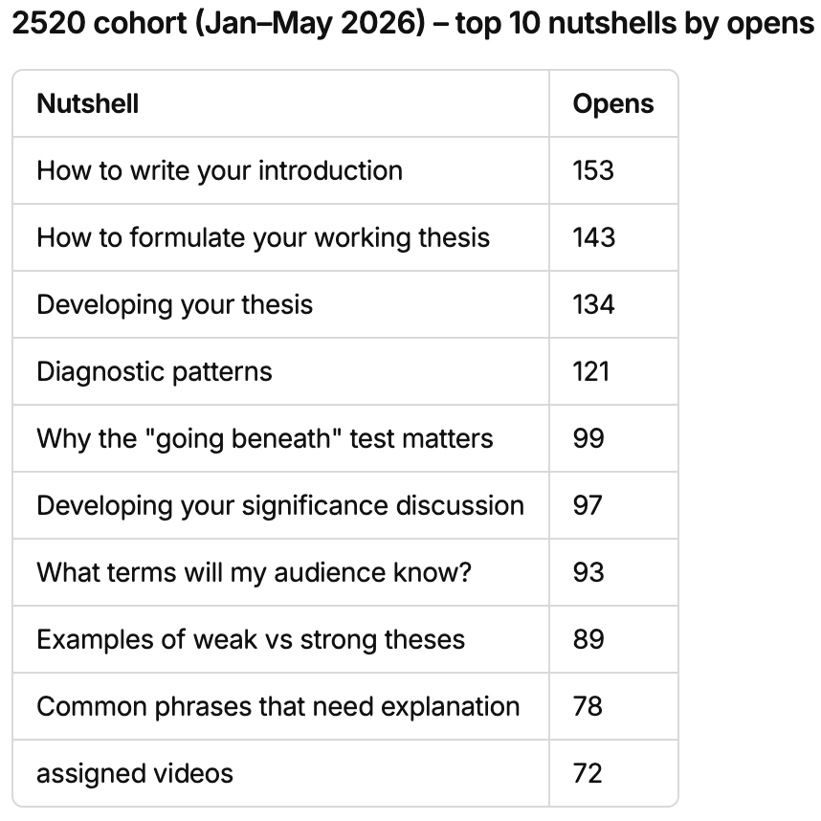
There are several ways we can think about “intended”. We can measure if it was opened at all and whether students spent a meaningful amount of time when opened. openNutshell is fired when a student clicks to open a nutshell. [Ask Kristen how inactive gets triggered and what it measures]

So, here what we can measure as of now using the data we have would be :

- Frequency of the amount of times particular nutshells were opened by the students over the term
- Which nutshells are the most/least opened?

First of all, for the frequency of nutshell visits over the term, we have the following tables :
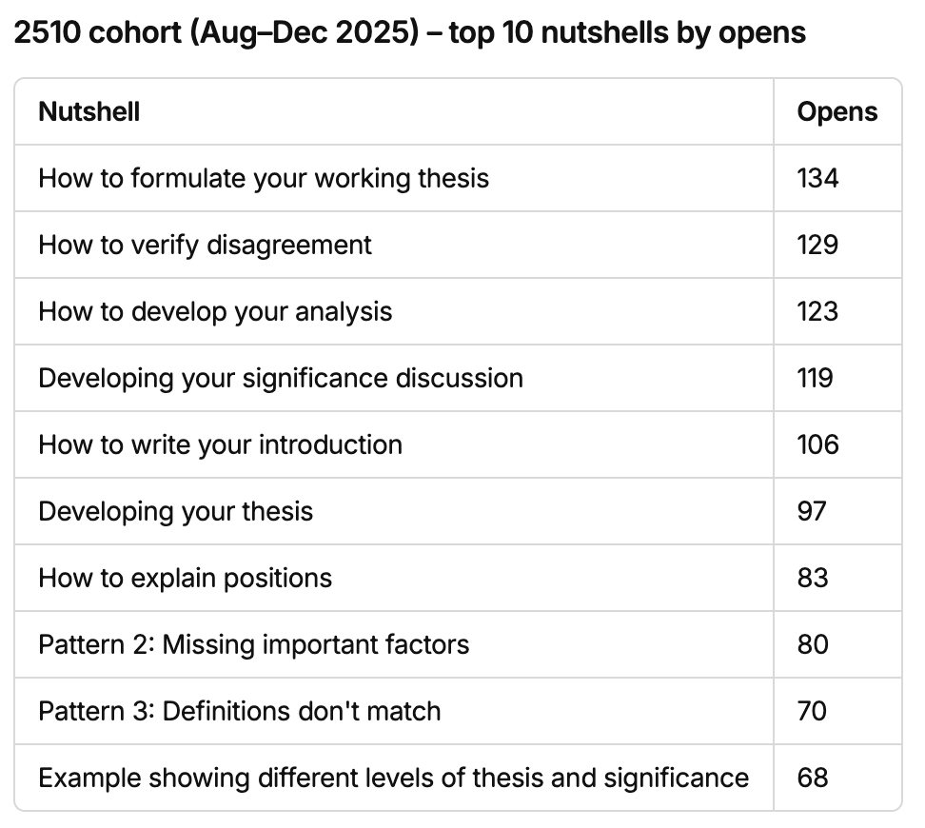

This table solely tells us about which nutshells were opened how many times. And, as we have analyzed before, we know that 19~22 unique students were opening the nutshells, meaning that it wasn’t only a few students clicking the nutshells frequently. As we intended, all students participated in clicking the nutshells.

In addition to the frequency of nutshells being opened, we can think about which were the most opened and closed nutshells throughout the term. This would indicate which topics were students’ interests, meaning which nutshells may have helped out the students a lot throughout their semester. As the most famous nutshells (as shown above) are related to “writing” and “thesis”, nutshells were mainly used when writing papers, and as we have seen in the previous analysis, the duration when the nutshells were seen was close to the due date for the final paper. Hence, the nutshells were used well at the right time.

Future Analysis Aspects / Data Required

1) New Questions I thought of

- What can we do to let the students use the website as intended?

- What were the pages students visited the most throughout the term? What were the most famous ones?

- What can we do to let the students use the website as intended?

- What were the pages students visited the most throughout the term? What were the most famous ones?

2) What would we want to know next year?

This section talks about these questions : What would we want to know next year? And what data do we need for that?

In my opinion, we really need to think about how to define “a student concentrated / engaged / focused”. We can currently measure the frequency of the events such as pageview and internalLinkClick, so we know which events or features have been used, but now I guess it is time for us to measure “after visiting a page, which other pages did the users tend to go to?” (just like question 1 of the “what do we know using our current data?” section at the top) Since we are analyzing the students’ “behavior” within the website, one action that can be defined would be their sequential data that has not been measured for this internship as we had to first determine what data we have now and what we can measure. This would let us know whether the students wandered around randomly or the pages they visited are relevant, which may give us an idea whether the student “focused” within the topic they are supposed to focus at that moment.

